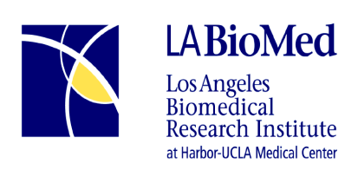

Job Announcement

Job Title: MCH Specialist I/Lactation Consultant (IBCLC)
Status: Full Time
Job requisition # 17-098
Dept.: SLAHP
Position Open Date: 09/11/17
Compensation: $3640- $5512

* If you are unable to apply following our standard procedures and need accommodation, please contact us at (310)222-3616.

Required Skills & Qualifications:

This position requires certification as an International Board Certified Lactation Consultant (IBCLC); high school diploma or equivalent; broad and in-depth knowledge of breastfeeding and lactation management, including in complex situations; at least two years of experience counseling and supporting breastfeeding mothers in WIC or similar populations; effective counseling, education, and coaching skills utilizing participant centered techniques, and motivational interviewing. Strong verbal and written communication skills are essential; proficiency in English and Spanish is required. Excellent organizational skills, basic keyboard skills and keyboard experience are needed to utilize required databases. Must have personal vehicle, valid California driver’s license, and current registration as well as proof of current auto insurance. Background check and health clearance are required.

Description of Duties:

- Provide breastfeeding education and support to breastfeeding mothers referred by Peer Counselors and other WIC staff, in person and by telephone
- Document client interactions as required in the Peer Counselor and WIC databases
- Coach and mentor breastfeeding peer counselors as requested
- Work closely with Special Nutrition Services staff who see mothers, babies, and children at high nutritional and medical risk
- Assist with SLAHP staff trainings
- Participate in SLAHP committees and collaborate with staff in other SLAHP Units, and the community
- Exercise sound judgment based in knowledge of SLAHP and State WIC policies, practices, and procedures
- Other duties as assigned

“Equal Opportunity Employer”
Please apply on-line @ www.labiomed.org

